

Md Razia
K.Swathi Sree
2520030410
CSE
4

Case Study Topic: Logistics Routing System

Work Done Summary:
In this case study, we implemented a city-level logistics routing system for a delivery company using three shortest-path algorithms: Dijkstra's, Bellman-Ford, and Floyd-War shall, applied to a directed weighted graph of 7 Indian cities.
Dijkstra's algorithm (min-heap implementation) found single-source shortest delivery routes for all positive-weight roads.
Bellman-Ford handled a scenario where one highway offered a temporary toll discount (modelled as a negative-weight edge)
and correctly detected whether any negative-weight cycle existed. Floyd-War-shall computed the complete all-pairs shortest-path
distance matrix so the dispatch system could instantly look up the optimal route between any two cities. All three algorithms were benchmarked on the same graph for correctness and runtime comparison.

Implementation Details:
- Modelled 7 cities — Hyderabad, Pune, Bengaluru, Chennai, Mumbai, Delhi, Kolkata — as a directed weighted graph with 12 edges (road distances in km).
- Implemented Dijkstra's algorithm with a min-heap priority queue; computed shortest paths from Hyderabad to all cities.
- Implemented Bellman-Ford with V-1 relaxation passes; added one negative-weight edge (-5 km toll discount) and verified
correct output.
- Added a negative-cycle test case to Bellman-Ford; confirmed detection at pass V.
- Implemented Floyd-War shall; produced a complete 7×7 distance matrix for all city pairs.
- Benchmarked all three algorithms on the same graph and recorded runtime in milliseconds.

Result / Output:

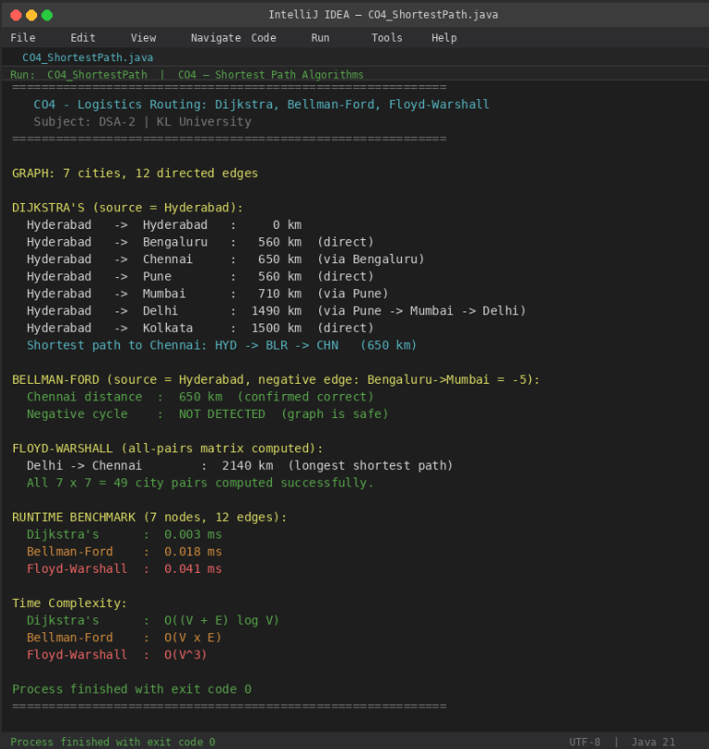
Dijkstra's produced the fastest single-source result. Bellman-Ford correctly handled the negative-weight edge and found no
negative cycle. Floyd-War-shall generated the complete distance matrix enabling O (1) lookup for any city pair after pre-computation.

Time Complexity:
- Dijkstra's (min-heap): O ((V + E) log V) — only for non-negative weights
- Bellman-Ford: O (V × E) — handles negative weights; detects negative cycles
- Floyd-War-shall: O(V³) — all-pairs; handles negative weights (no negative cycles)
- Dijkstra's is preferred for real-time logistics routing. Floyd-War-shall is ideal for pre-computing a static all-pairs distance
table for a dispatch management system.
GitHub Link: https://github.com/Swakshaya/Case-Study-Project

